*Smart Farm*

*Monitorig Device*

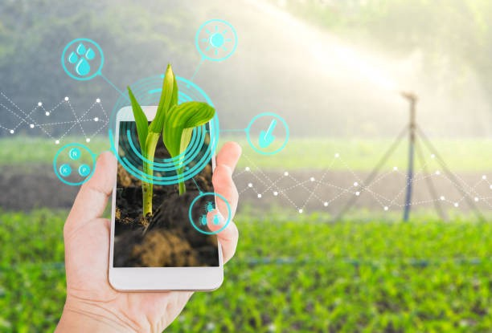

SMART FARMING

### A Project Work Report

*Submitted in the partial fulfillment for the award of the degree of*

# BACHELOR OF ENGINEERING

### IN

### COMPUTER SCIENCE (IOT)

### Submitted by:

### RAGHAV GOEL

### (18BCS4505)

### Under the Supervision of:

### RANA GILL



### CHANDIGARH UNIVERSITY, GHARUAN, MOHALI - 140413,

**PUNJAB**

#### SEPTEMBER 2020

**Student Declaration**

I, Raghav Goel , hereby declare that the presented report of Project titled “ **Smart Farming”** is prepared by me after the completion of four months’ work at Chandigarh University.

I also confirm that the report is only prepared for my academic requirement, not for any other purpose. It might not be used with the interest of the opposite party of the corporation.

…………………………….  
**Raghav Goel**

**Be-Cse(iot)**

**18AITIOT1**

**18BCS4505**

**Acknowledgement**

The success and final outcome of this project required a lot of guidance and assistance from many people and I am extremely privileged to have got this all along the completion of my project. All that I have done is only due to such supervision and assistance and I would not forget to thank them.

I respect and thank **Mrs Rana Gill**. for providing me an opportunity to do the project work in **Chandigarh University** and giving us all support and guidance, which made me complete the project duly. I am extremely thankful to her for providing such a nice support and guidance, although he had busy schedule managing the corporate affairs.

I am thankful to and fortunate enough to get constant encouragement, support and guidance from all Teaching staffs of Be-Cse (IoT) which helped us in successfully completing our project work. Also, I would like to extend our sincere esteems to all staff in laboratory for their timely support.

**Raghav Goel**

**18BCS4505**

# Table of Contents

Title Page Abstract

List of Figures

i ii iii

#### INTRODUCTION 1

* 1. Problem Definition 1
  2. Project Overview/Specifications* (page-1 and 3) 2
  3. Hardware Specification 3
  4. Software Specification 4

1. LITERATURE SURVEY 5
   1. Existing System 5
   2. Proposed System 6
2. CIRCUIT DIAGRAM
3. **METHODOLOGY**
4. **CONCLUSION AND RECOMMENDATION**
5. **REFFERENCES**

***ABSTRACT***

With the increasing growth in population the conventional methods of farming are unable to cope up and advancement in farming methods has become a necessity. Therefore, many smart farming systems are being developed to overcome such problems. The smart farming system can benefit us in various ways such as an increase in production, water conservation, real-time data and production insight, lowered operation costs, increase in quality of production, accurate farm and field evaluation, remote monitoring, equipment monitoring etc. In this system smart farming is done based on Internet of things which enables multiple devices to interact with each other to produce required information. In this model the use of sensors for measuring environmental parameters required for the crops. It also includes node MCU and various sensors for executing the whole process. Also, a web page is constructed to store the data and display to the farmers. This system will help farmer to increase the crop yield by eliminating various risk factors involved in the farming.

vii

***List of Tables***

##### Table Title page

***3.1*** *Quantities of Materials Required in the Designs with Different* ***10***

*Grades of Concrete*

|  |  |  |
| --- | --- | --- |
| **SR.NO** | **MATERIAL** | **REQUIREMENTS** |
| 1 | Nodemcu Esp8266 | 1 PIECE |
| 2 | DHT11 | 1 PIECE |
| 3 | Soil moisture sensor | 1 PIECE |
| 4 | JUMPER WIRES | 10 PIECES |

viii

# INTRODUCTION

#### 1.1 India has the highest illiteracy rate despite of the fact which socioeconomic group one belongs to and if we see Indian rural areas especially the agriculture communities, we might get that the increasing illiteracy rate comprises them as a wider part. Agriculture contributes about 18% of the India’s GDP. Yet agricultural sector is the most under-privileged in terms of technology and finance. More than 3000 farmers die every day due to unavailability of resources, technology, money etc. if we imply smart farming techniques, the illiterate farmers can monitor their fields while sitting at the home in less resources and cost-effective manner without human intervention. No bulky machinery would be required. Following activities can be taken care of- weed control, water level, automatic water dispenser etc. while implementing this technology we make our farm as a smart farm and will provide us better yield.

**1.2** the illiteracy rate is high , due to which the farmers cannot look after their fields properly and they need a helping hand ,So if we develop a new smart farming project which will monitor the field will be much more helpful for the farmers . In this system we will be using the sensor which will monitor the field humidity and temperature if the fields does require the water or not , now the collected data will be sent to nodemcu which is used for wifi connectivity to the sensor and this will collect and decode the data received from the sensor,now nodemcu will send the data to the sql server the data will be stored in the server and now the stored data will be visible on the web page as the information,this will help the farmer to monitor the field and it is much more cheaper than the other products available, this will be the biggest step towards the Smart India project as we know that this includes IoT , so it will also help in the development of IoT

**1.3 Hardware Specification**

* Node cu Esp8266: - The NodeMCU ESP8266 is a **low-cost WiFi module** built by Espressif Systems. Its popularity has been growing among the hardware community thanks to its nice features and stability, to the point that it can be easily programmed using your Arduino IDE. For using it we need Arduino IDE version 1.7 or higher.
* Dht11 sensor (temp, humidity): - DHT11 is a Humidity and Temperature Sensor, which **generates calibrated digital output**. DHT11 can be interface with any microcontroller like Arduino, Raspberry Pi, etc. and get instantaneous results. DHT11 is a low cost humidity and temperature sensor which provides high reliability and long term stability.
* Soil moisture sensor: - Soil moisture sensor is used with nodemcu to measure the moisture of the soil.
* Jumper wires:- A jump wire (also known as jumper wire, or jumper) is an electrical wire, or group of them in a cable, with a connector or pin at each end (or sometimes without them – simply "tinned"), which is normally used to interconnect the components of a breadboard or other prototype or test circuit, internally or with other equipment or components, without soldering.

**1.4 Software Specification**

* **XAMPP** :- It is a [free and open-source](https://en.wikipedia.org/wiki/Free_and_open-source) [cross-platform](https://en.wikipedia.org/wiki/Cross-platform) [web server](https://en.wikipedia.org/wiki/Web_server) [solution stack](https://en.wikipedia.org/wiki/Solution_stack) package developed by Apache Friends, consisting mainly of the [Apache HTTP Server](https://en.wikipedia.org/wiki/Apache_HTTP_Server), [MariaDB](https://en.wikipedia.org/wiki/MariaDB) [database](https://en.wikipedia.org/wiki/Database), and [interpreters](https://en.wikipedia.org/wiki/Interpreter_(computing)) for scripts written in the [PHP](https://en.wikipedia.org/wiki/PHP) and [Perl](https://en.wikipedia.org/wiki/Perl) [programming languages](https://en.wikipedia.org/wiki/Programming_language)

# RESEARCH OBJECTIVES

The proposed research is aimed to carry out work leading to the development of an approach for smart framing. The overall objective of this study is to introduce a smart agriculture framework as an application of information and communication technology (ICT) to improve the conventional farming management in tropical agriculture production. The framework is implementing a cloud technology as a backbone, which can be extended with various knowledge such as data science, plant biology, plant physiology, bio-physical and bio-mechanical (agricultural robotics). To achieve the research objective above, we break down our work into 4 research themes as follows:

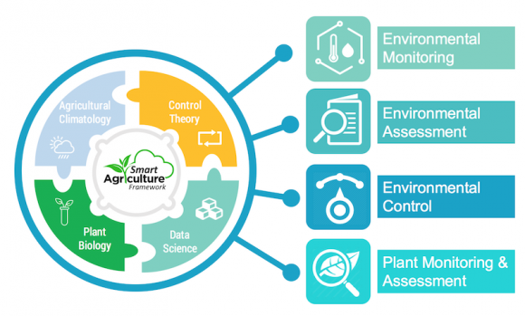

1. Environmental monitoring: - Environmental monitoring is the foundation of modern agriculture. By collecting the periodical weather data both real-time and long-term evaluation, the behavior and variation of hourly, daily, monthly, and yearly could be quantified for precise farming decision support. Remote environmental monitoring based on cloud technology could support the real-time and long-term evaluation on the tropical horticulture production under unstable network connection
2. Assessment of environment: - Environmental assessment is the second step in the utilization of smart agriculture framework in the tropical agriculture production. It is important to interpret the collected environmental data as a factor to support the decision making on farming management.
3. Environmental Control: -The suitable environmental condition is necessary to obtain the maximum plant growth during the agriculture cultivation. To achieve appropriate environmental condition, we consider the implementation of environmental control. In tropical agriculture, irrigation control is one of the applications that can be established by the smart agriculture framework for flexible and simple operation [1]. The irrigation control implemented on/off logic control for water supply according to the soil moisture content as input reference, called the sensor-based control
4. Plant monitoring and assessment: -

Plant monitoring and assessment is the activity to get responses of the environmental treatment from plant behavior’s view. Leaf motion is one of physical indicator that has been used to investigate the existence of plant motion, representing the internal movement triggered by the circadian clock even under the constant environmen

# CIRCUIT DIAGRAM

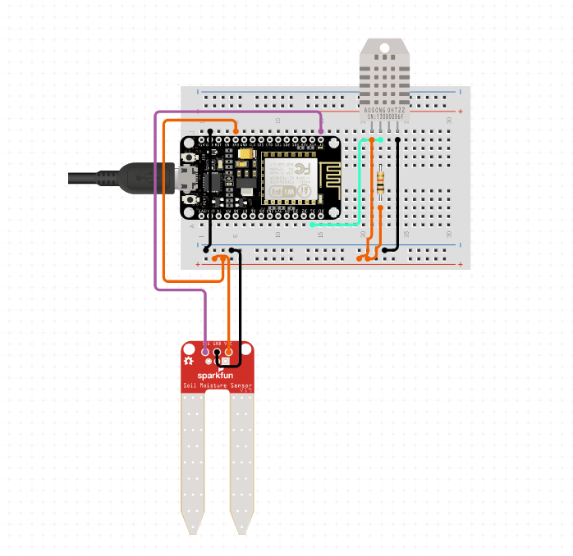

Soil Moisture Sensor

# DHT11

# Temperature and Humidity Sensor

Node MCU

# 5 METHODOLOGY

**WEBPAGE**

**PHP HOST, SQL DATA BASE**

**NODEMCU**

**sensor**

HUMIDITY AND TEMPERATUR SENSOR

SOIL MOISTURE SENSOR

COLLECT DATA

WIFI CONNECTIVITY

SEND DATA TO DATABASE

SENDS DATA

DISPLAY TO

DISPLAY DATA COLLECTED BY SENSOR



**ARDUINO IDE**

Soil moisture sensor

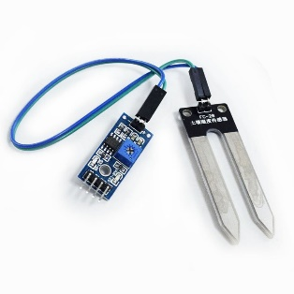 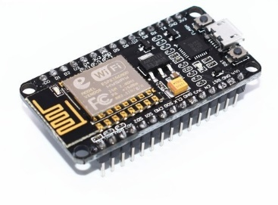

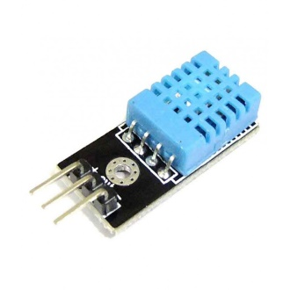

DHT11 sensor



XAMPP LOCAL HOST containing the SQL database in PHPMY ADMIN

**WEBPAGE**

1. **CONCLUSION AND RECOMMENDATION**

With a future of efficient, data-driven, highly precise farming methods we can use solar panels for power supply in the farms and deployments of the sensors. Power integration using solar panel will be very productive way for farmers and will help in deploying more variety of sensors like yield monitoring and mapping .Also Cloud computing technology can be added for making farmers to advise each other and discuss with each other on how exactly they could improve the growth of their crops.

**7 REFERENCES**

1. <http://dx.doi.org/10.1016/j.compag.2016.04.025>
2. <http://www.kresttechnology.com/krest-academic-projects/krest-major-projects/ECE/BTech%20%20Major%20ECE%20EMBEDDED%202016-17/Btech%20ECE%20Embedded%20Major%20BP%202016-17/3.%20Automated%20Irrigation%20System%20In%20Agriculture.pdf>
3. <https://ieeexplore.ieee.org/document/8538702>
4. <https://www.ijrte.org/wp-content/uploads/papers/v7i5/E1987017519.pdf>
5. <https://www.semanticscholar.org/paper/Smart-Agriculture-Based-on-Cloud-Computing-and-IOT-Tong-ke/fa7606fc2abe3d069efef6618d45da7a1dcb8bd5?p2df>
6. https://www.mouser.in/applications/smart-agriculture-sensors